SECTION-1 (HTML assignments)

1. Create an empty directory ‘Assignments’ & cd to ‘Assignments’.

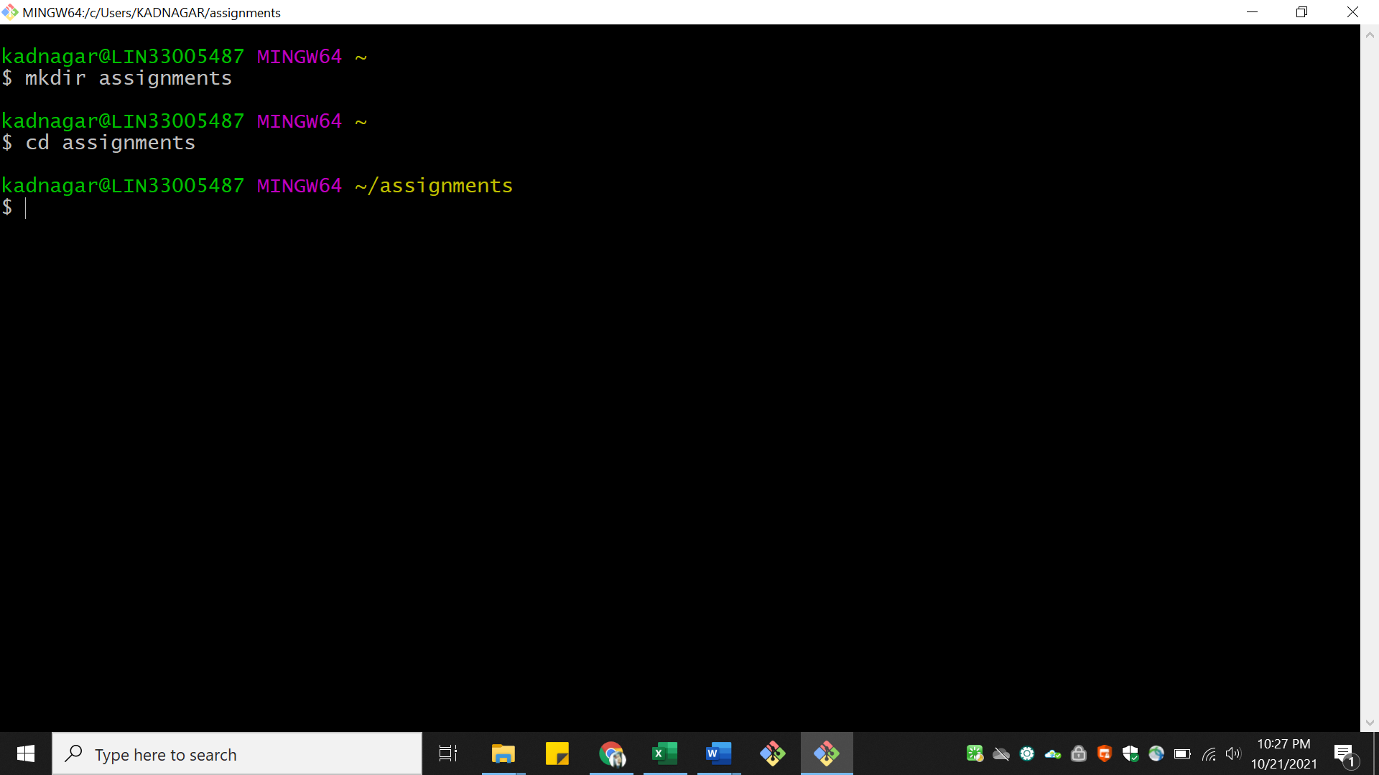

23.Create a file README.txt inside ‘Assignments’ & write few lines about the contents of ‘Assignments’ folder.

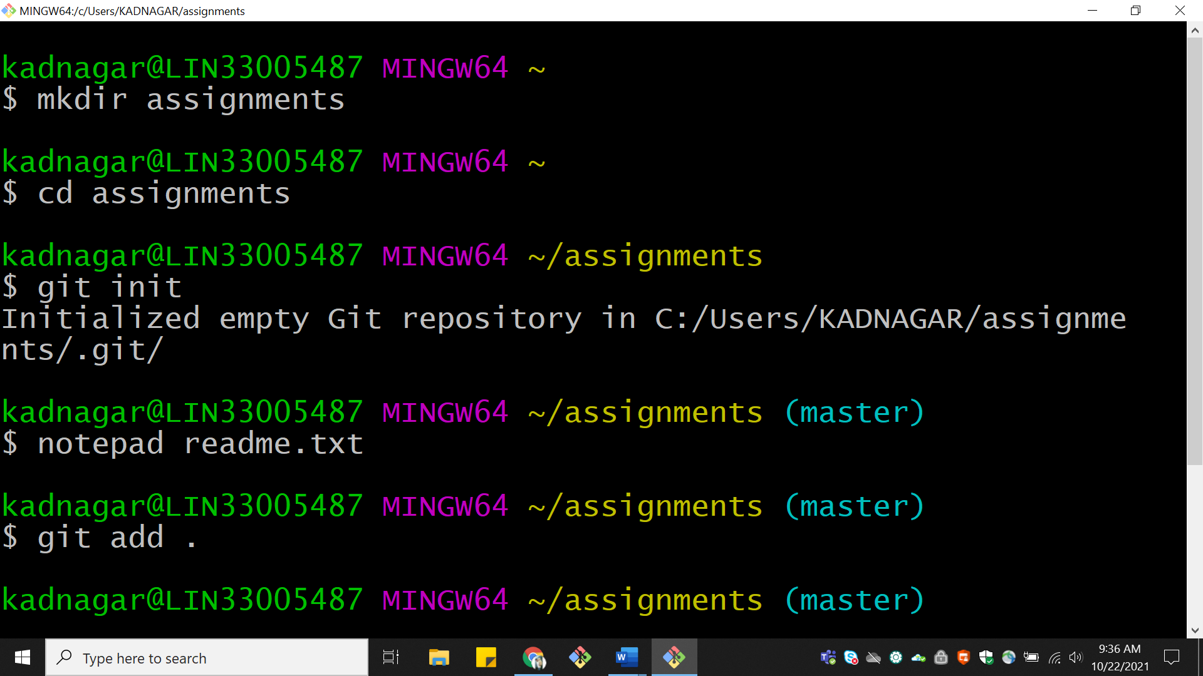

24.Commit README.txt file.

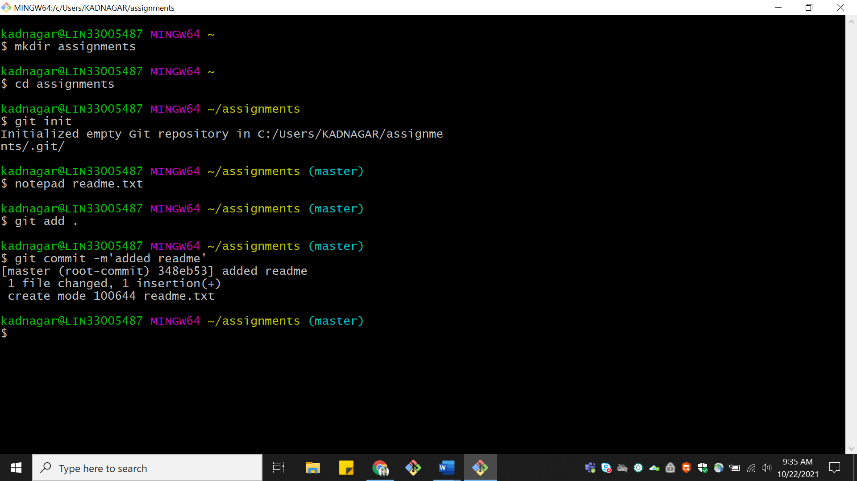

25.Now create a new branch ‘html-assignments’.

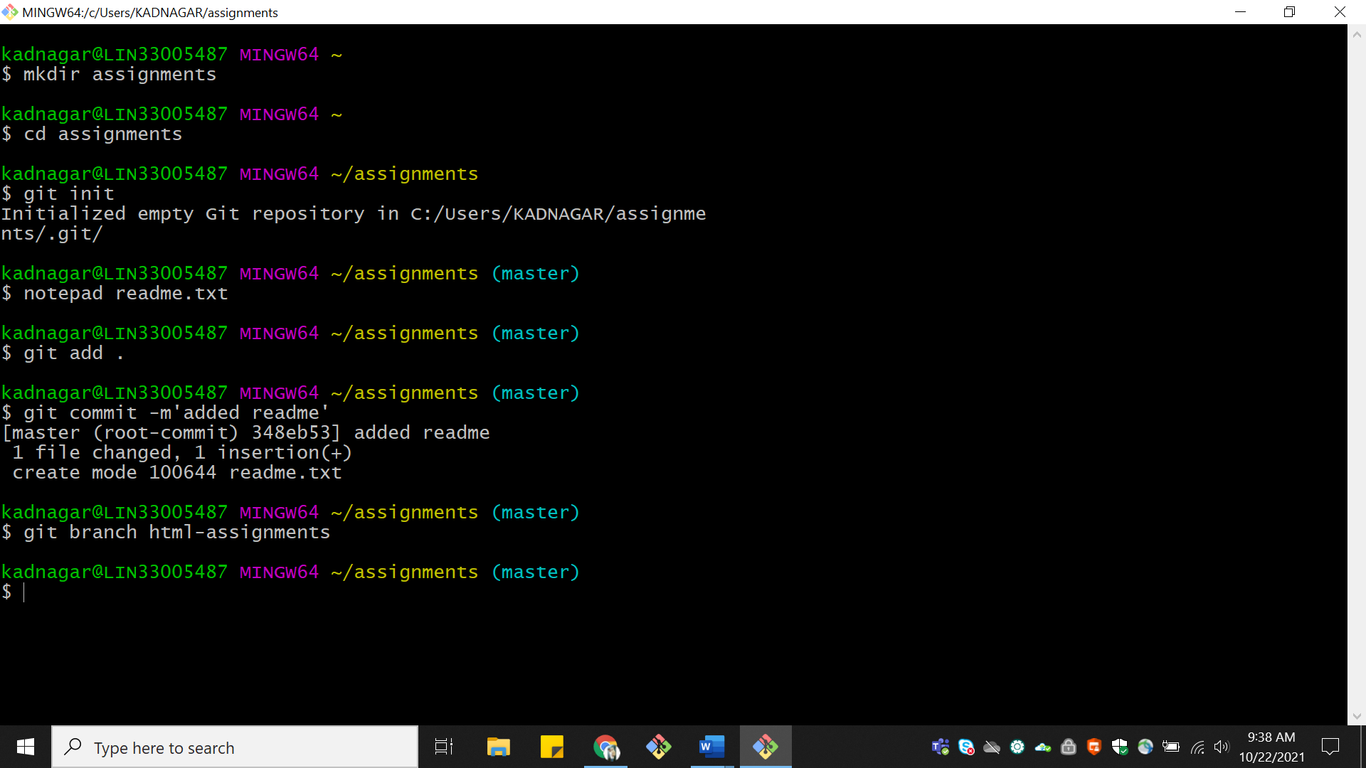

26.Switch to ‘html-assignments’ branch.

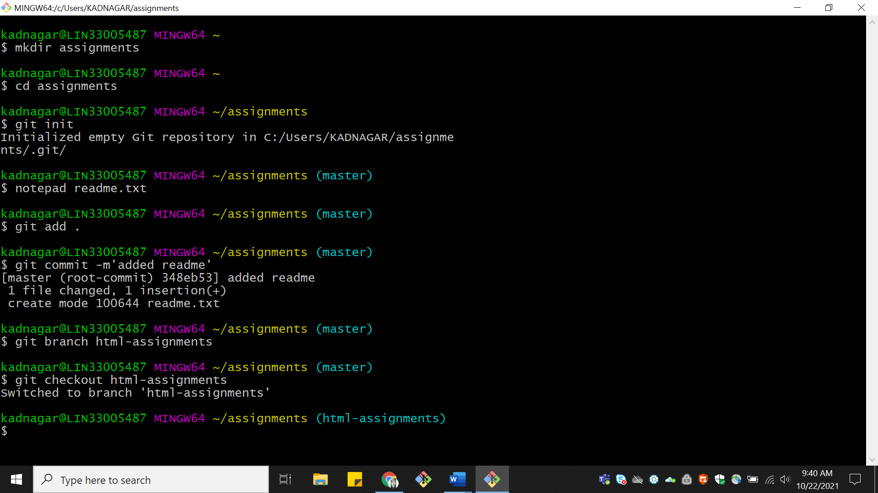

27.Copy all HTML assignments inside ‘Assignments’ folder.

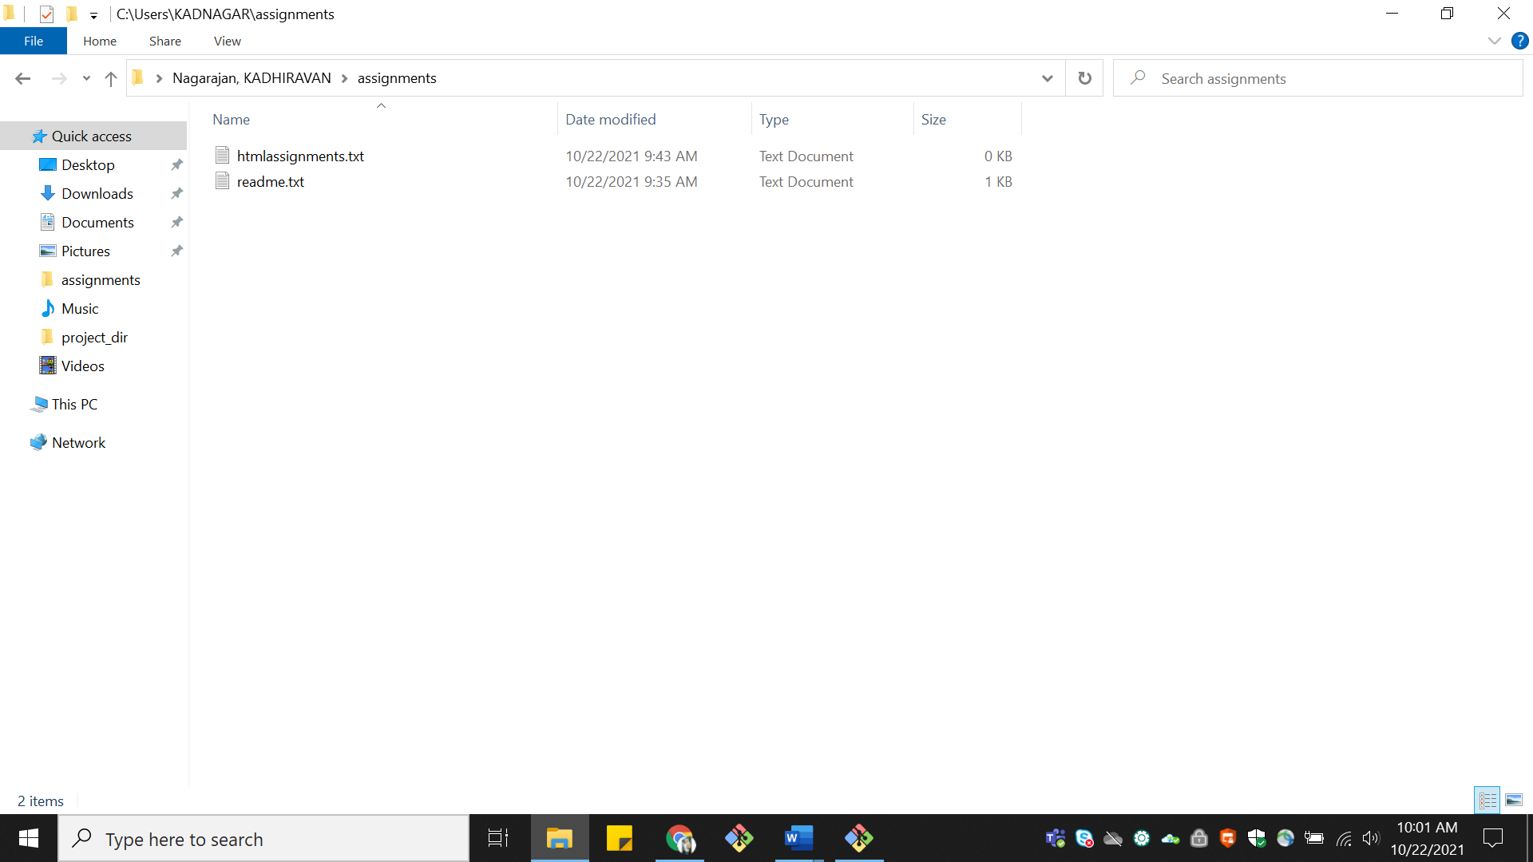

28.Commit HTML assignments into ‘html-assignments’ branch.

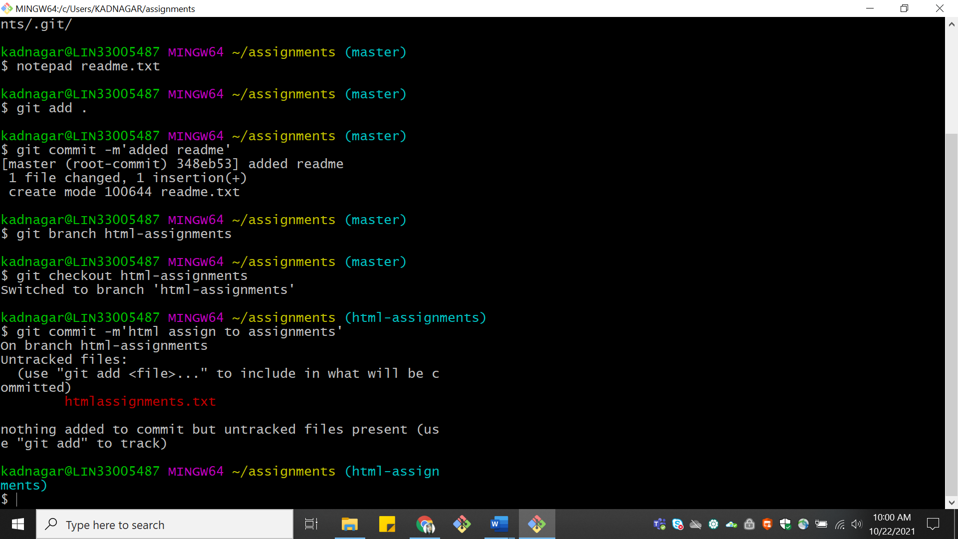

29.Make minor changes into few files belonging to ‘html-assignments’ branch.

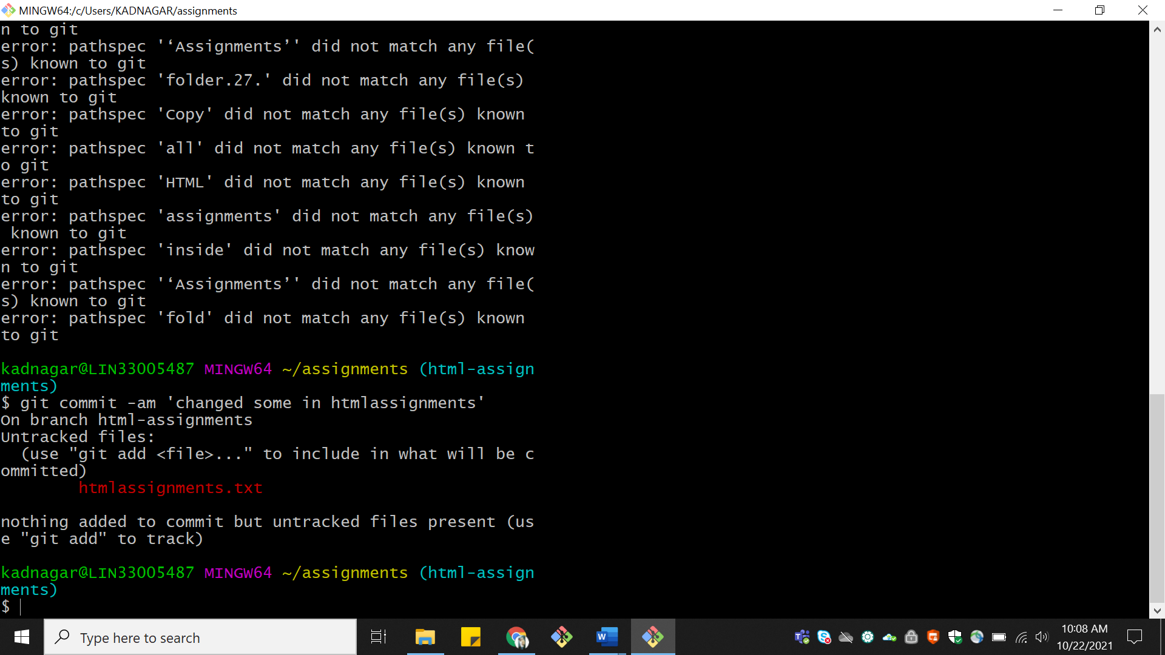

30.Commit those changed files. 31.Switch to master branch.

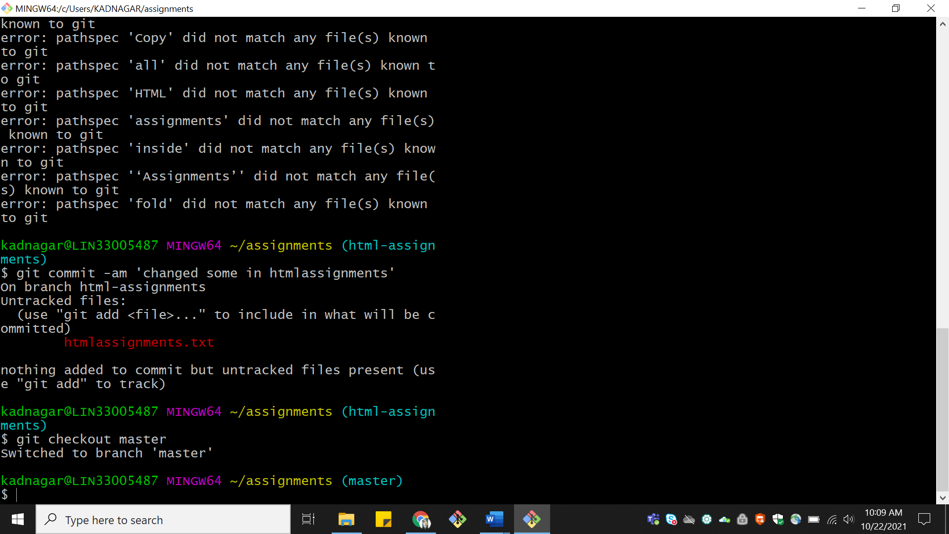

32.Make minor changes into README.txt file & commit those changes into master

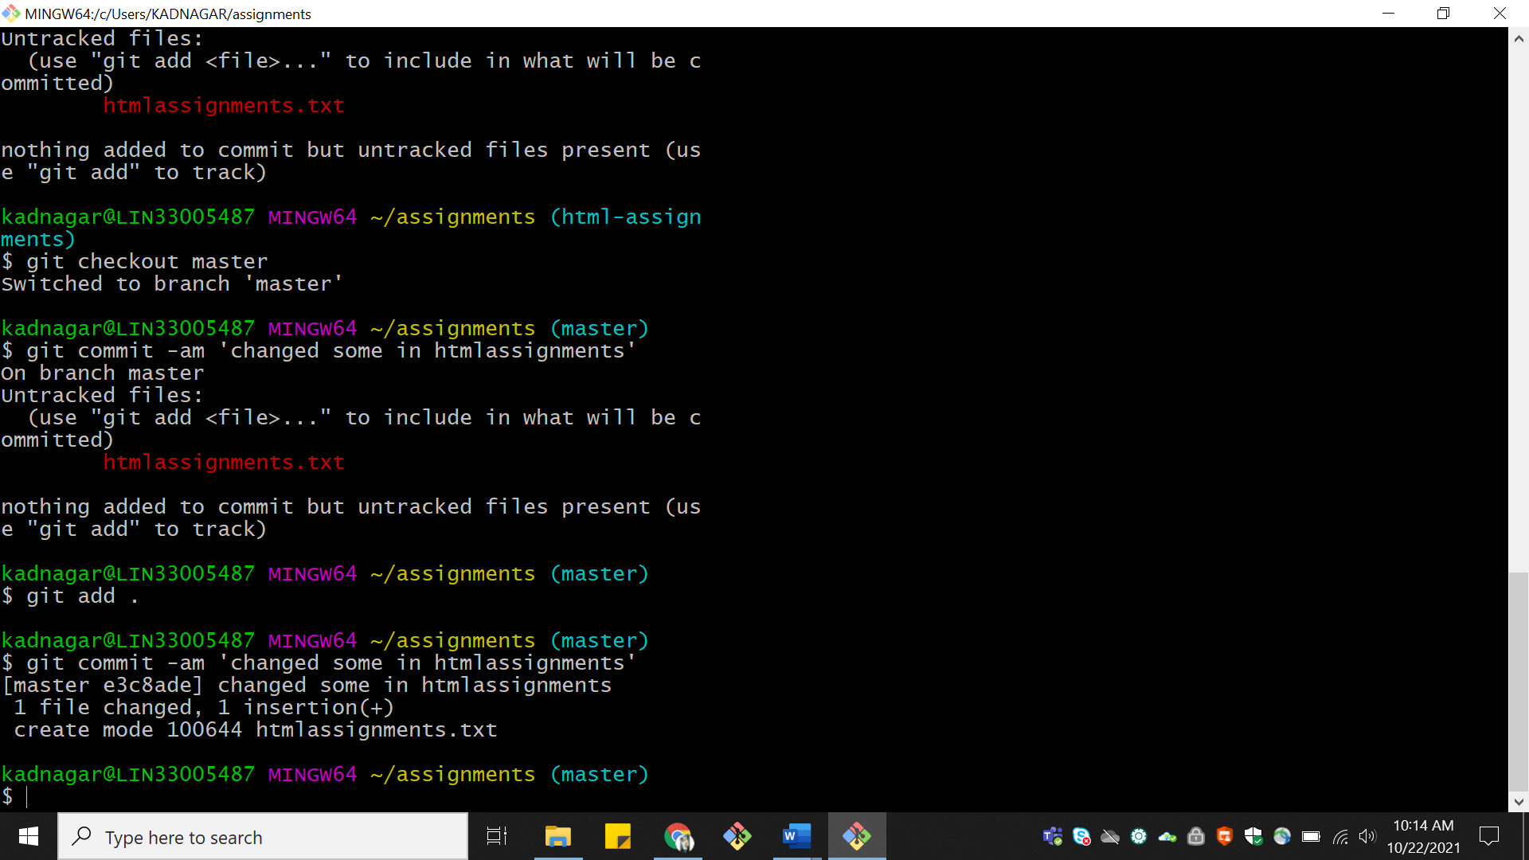

33.Again switch to ‘html-assignments’ branch.

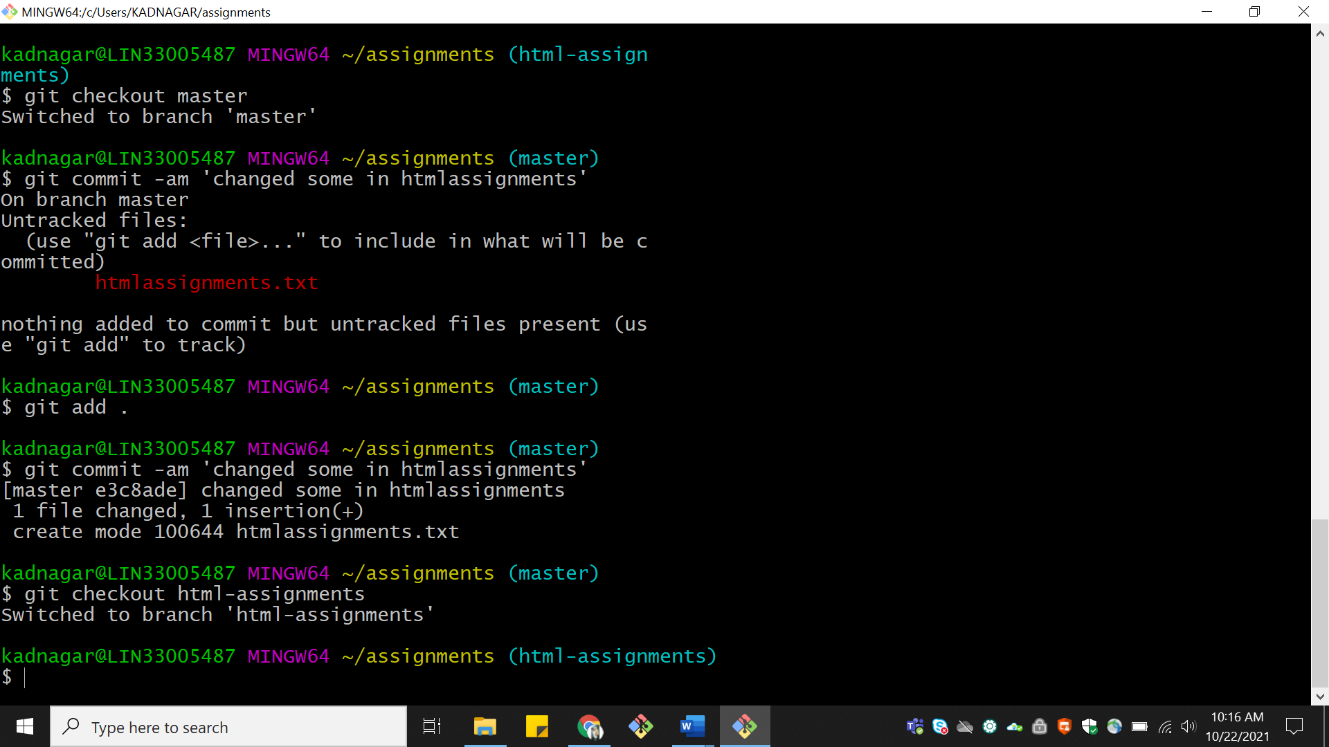

34.Make minor changes into few files belonging to ‘html-assignments’ branch

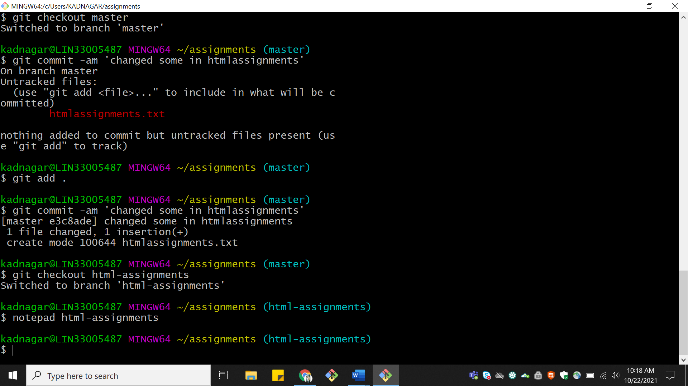

35.Commit those changes.

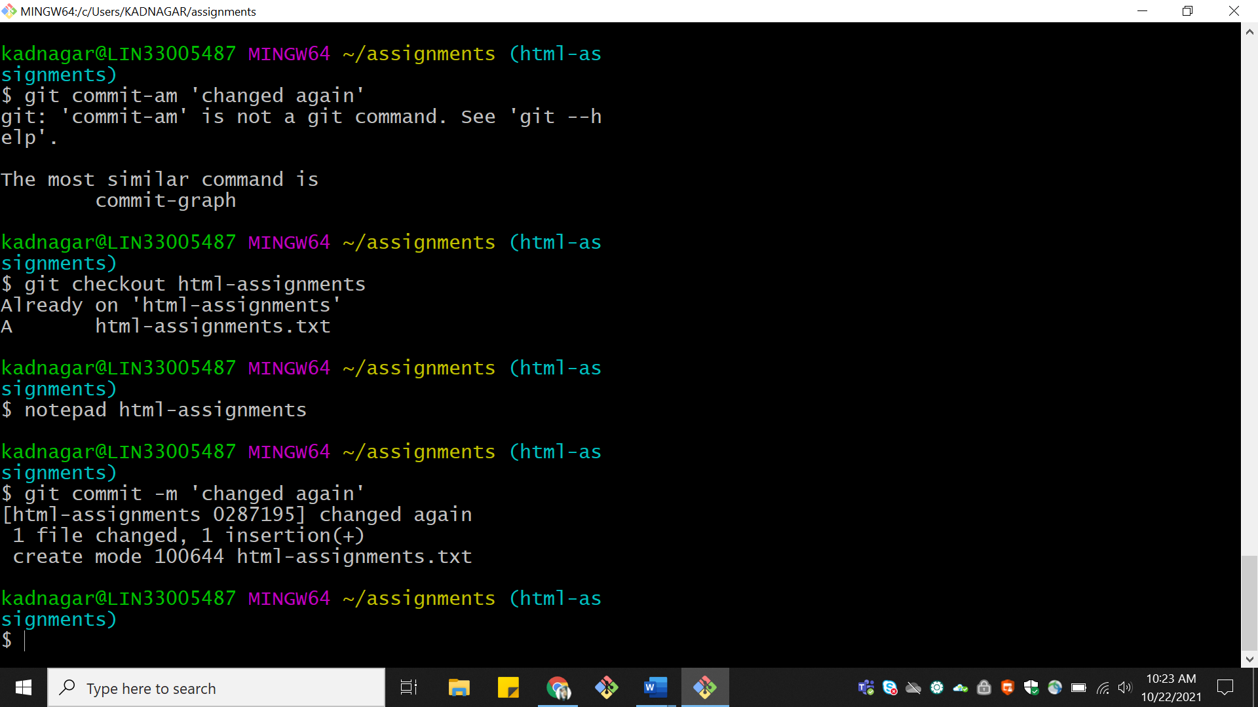

36.Switch to master.

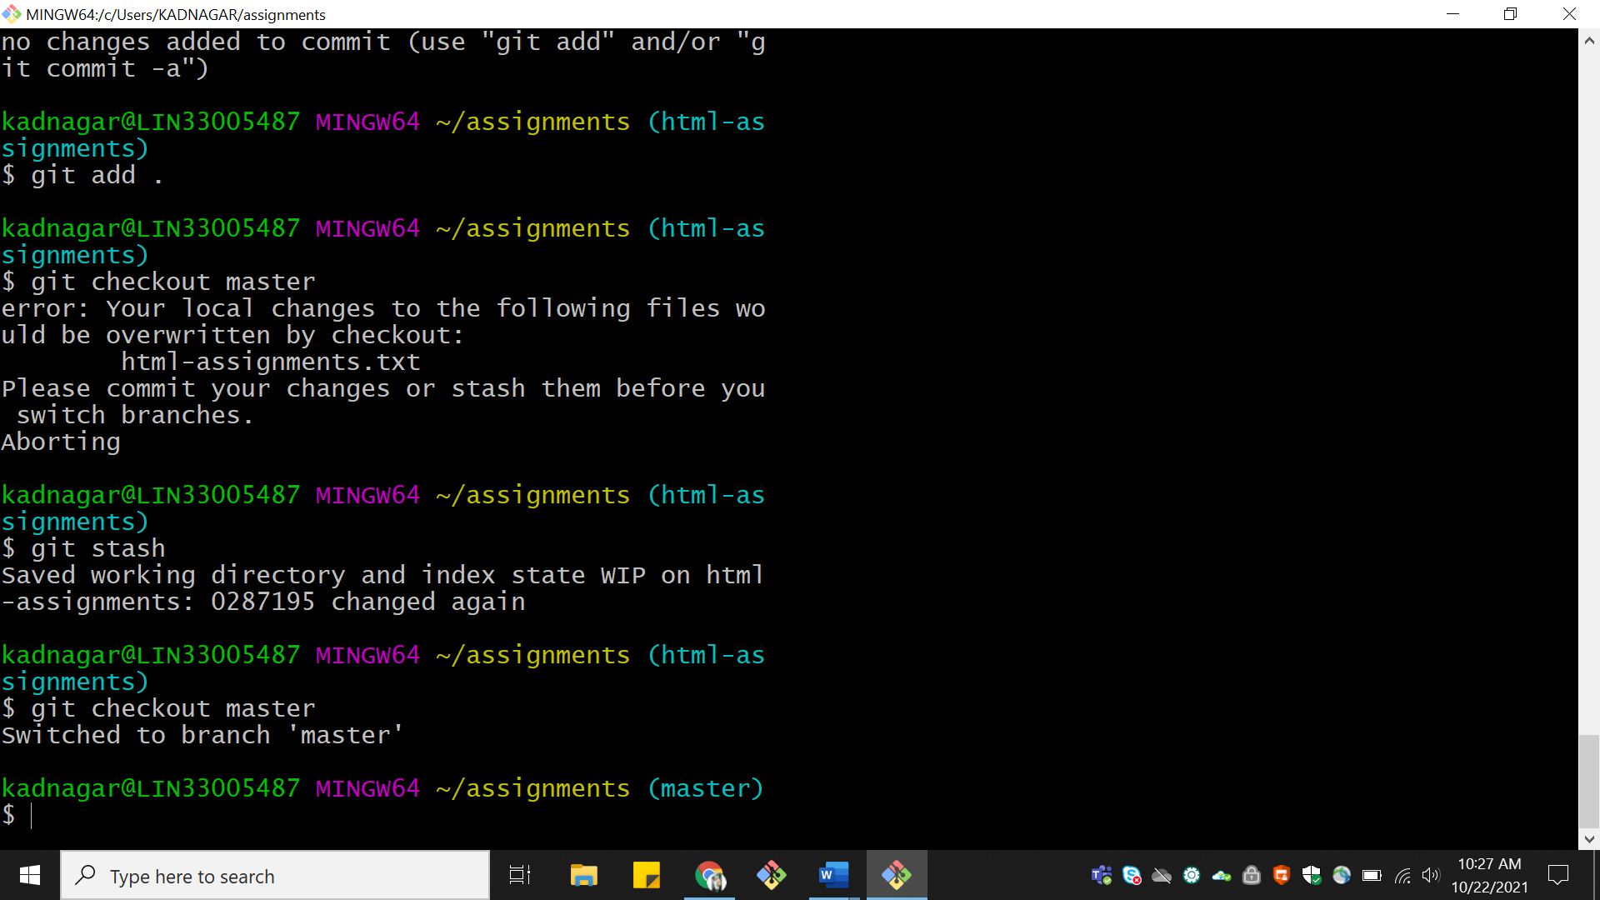

37.Merge ‘html-assignments’ branch into master. Confirm all html assignments are shown in master.

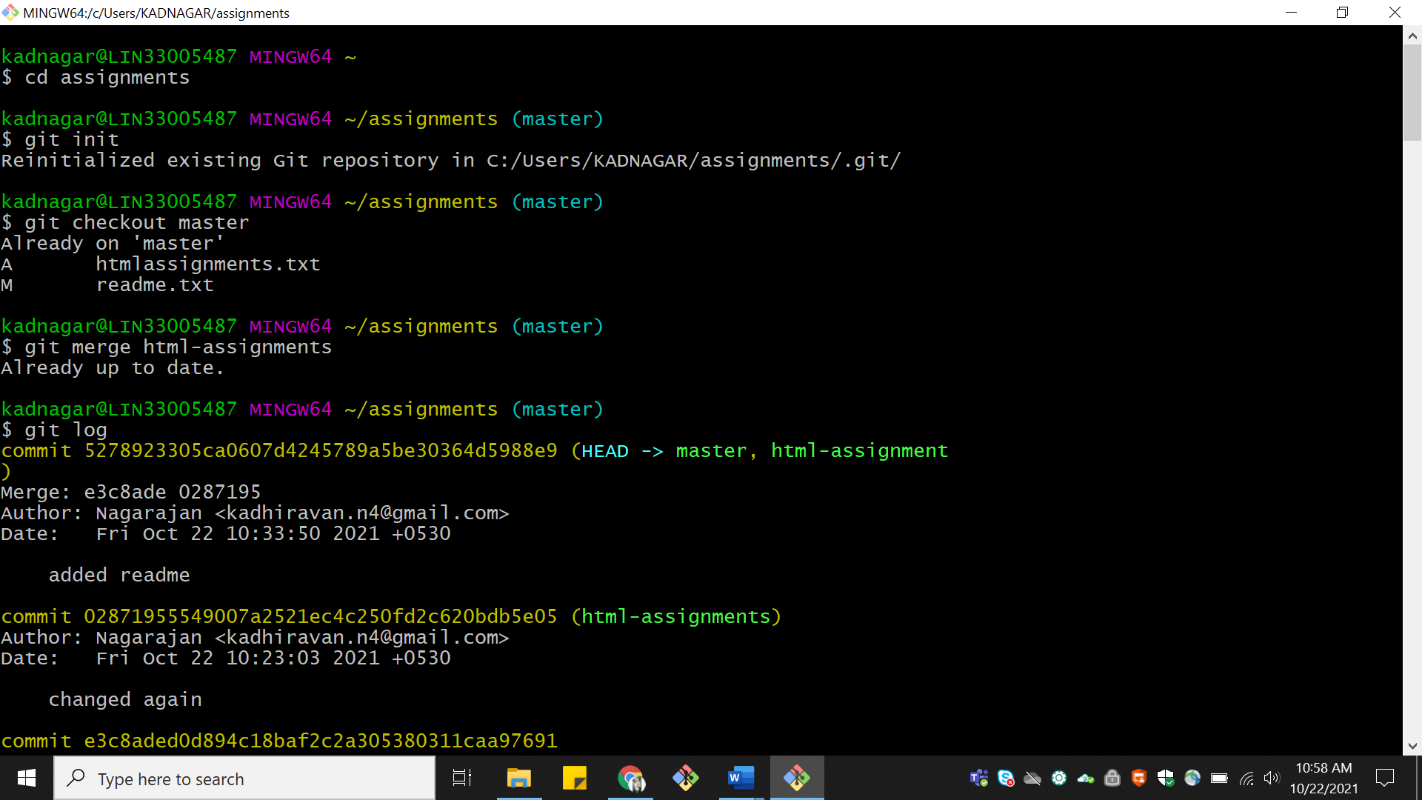

38. Finally delete the ‘html-assignments’ branch.

